ABDULLAH KHAN

2020024

First I am doing Preprocessing on the data. I am doing Label Encoding with the help of one hot encoding of labels. For Data normalization I am dividing data by 255 and converting data to float 32 as float 32 is supported by tensorflow functions.

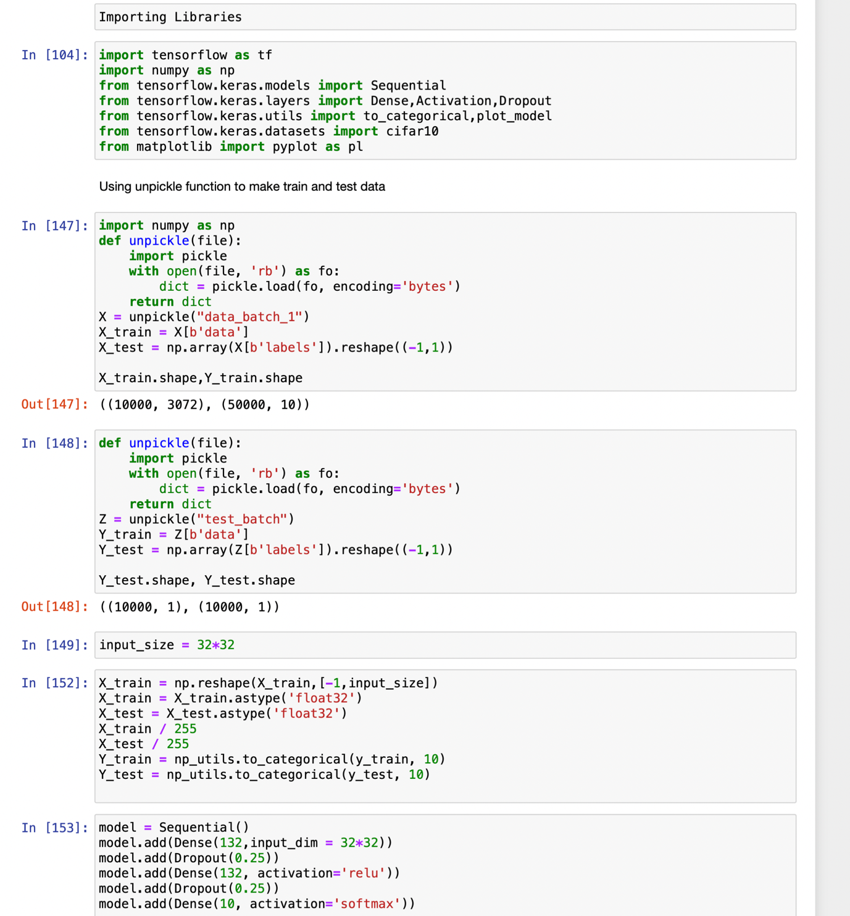

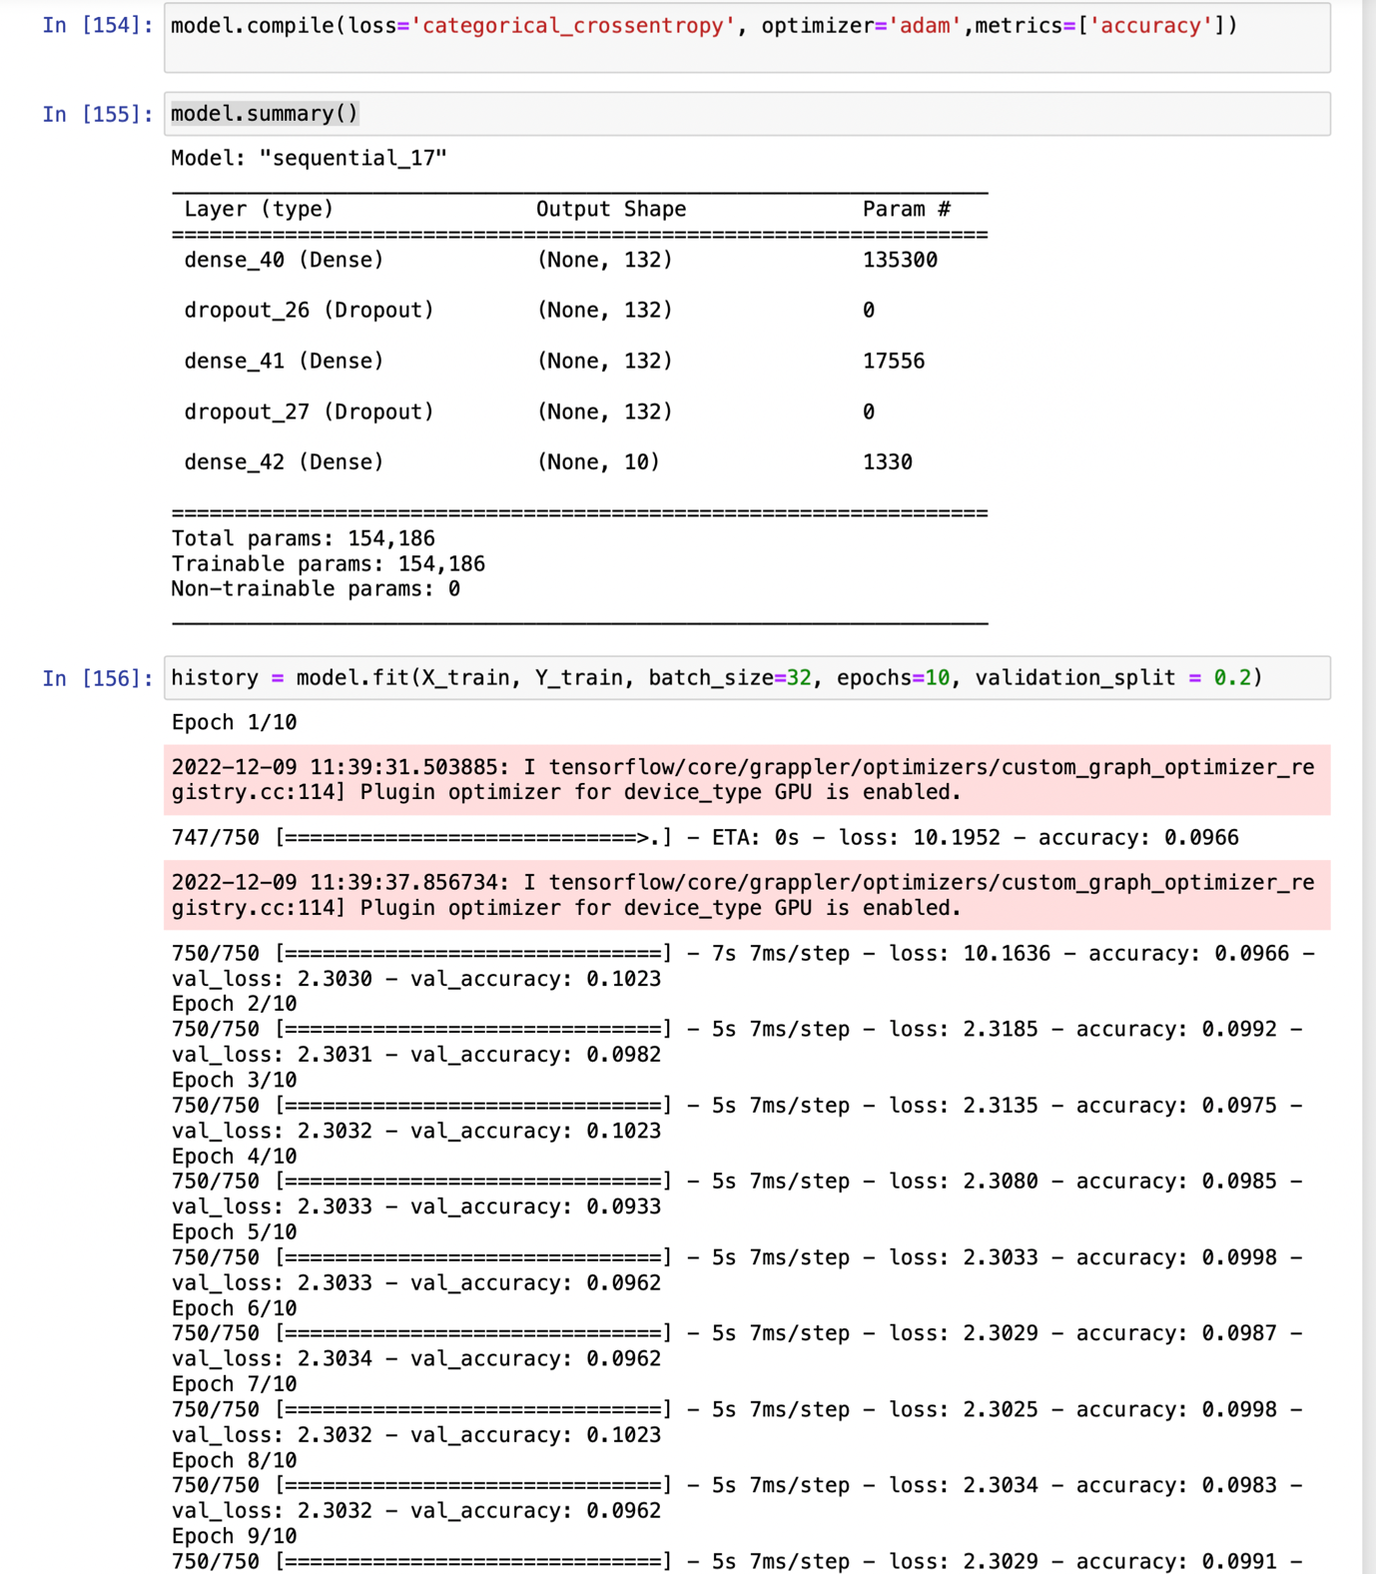

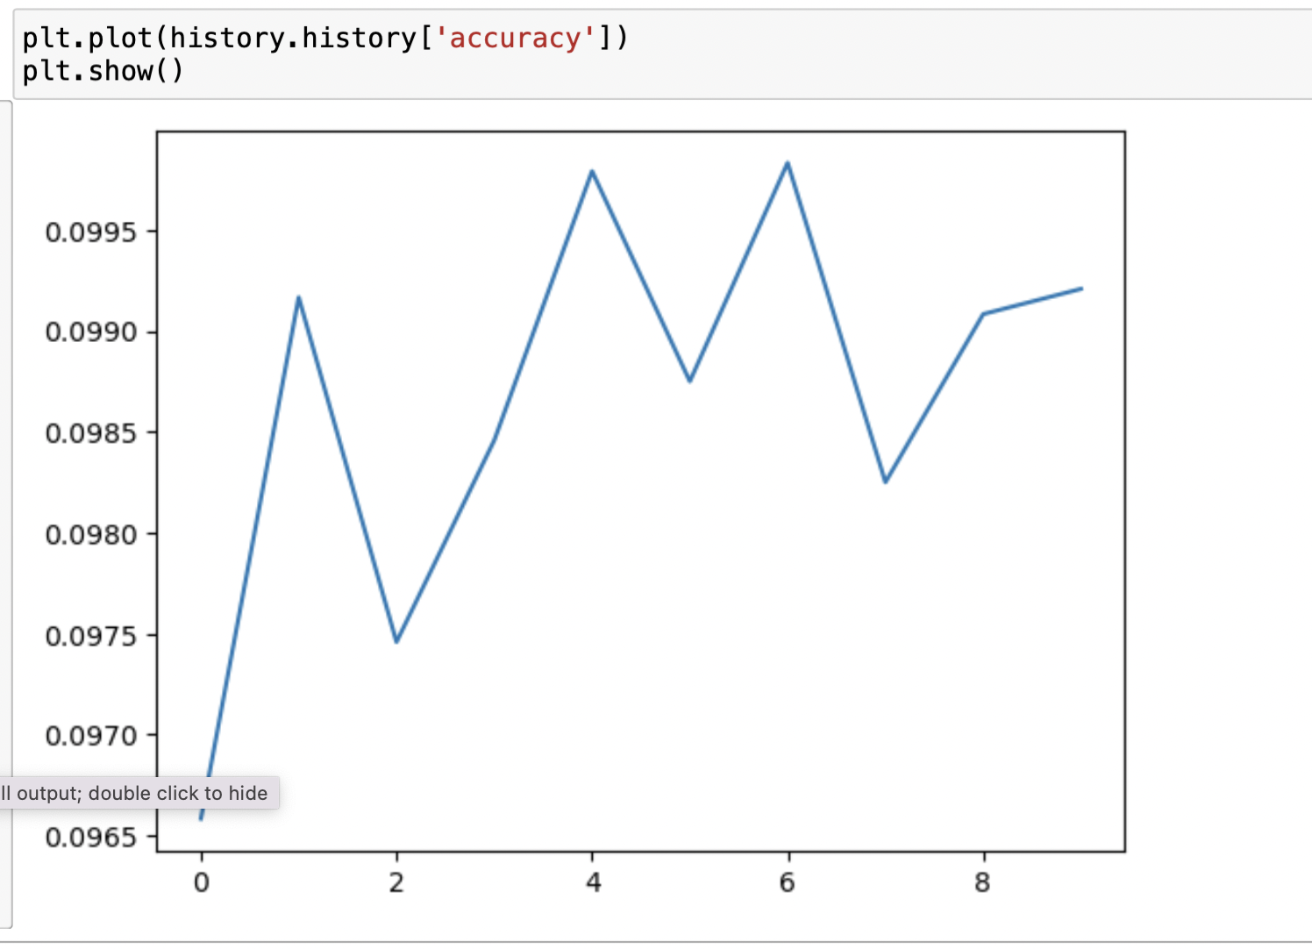

HYPERPARAMETER TUNING

With these hyperparameters, as you can see accuracy is too low. Now changing hyperparameters,

I felt that underfitting is happening on observing so decreasing dropout to 0.1. As you can see below on decreasing dropout the accuracy increased a bit.

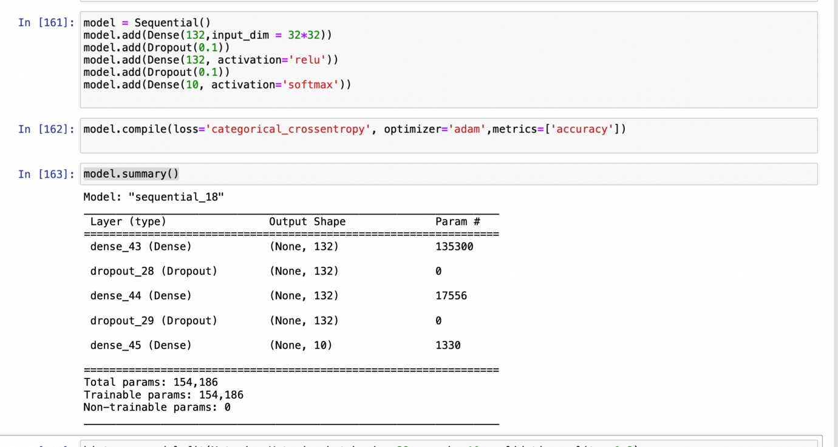

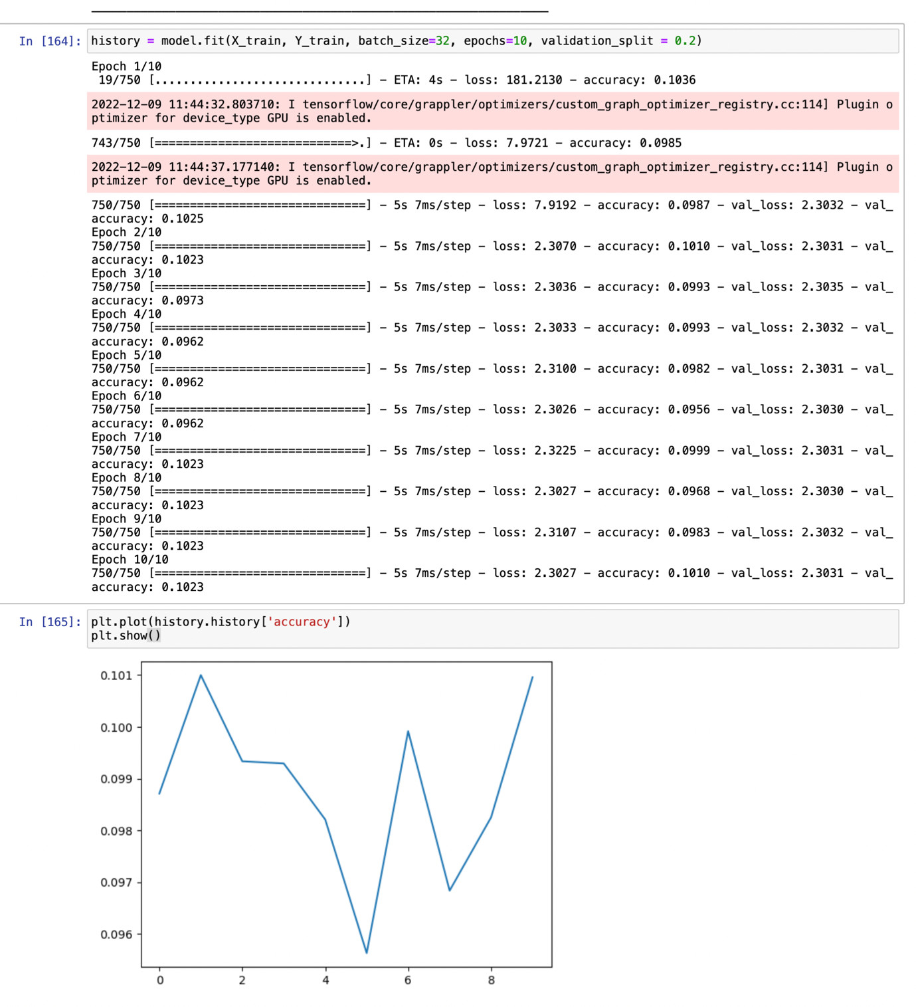

Now changing the activation function to tanh and no. of neurons to 150.

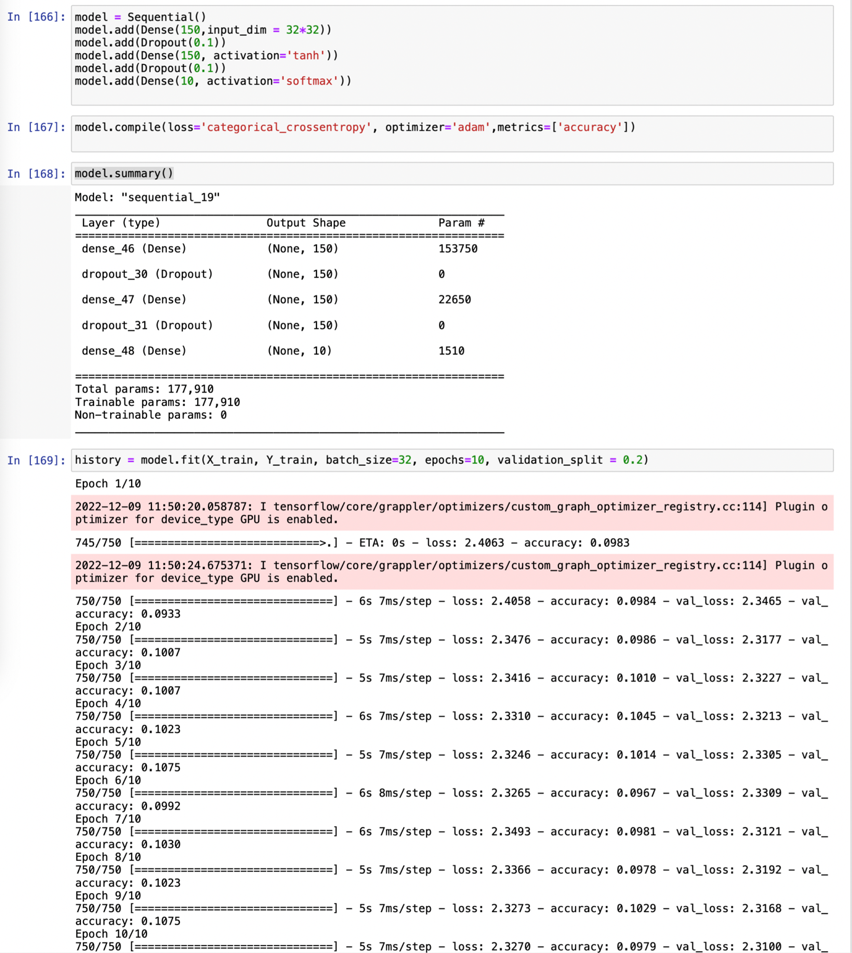

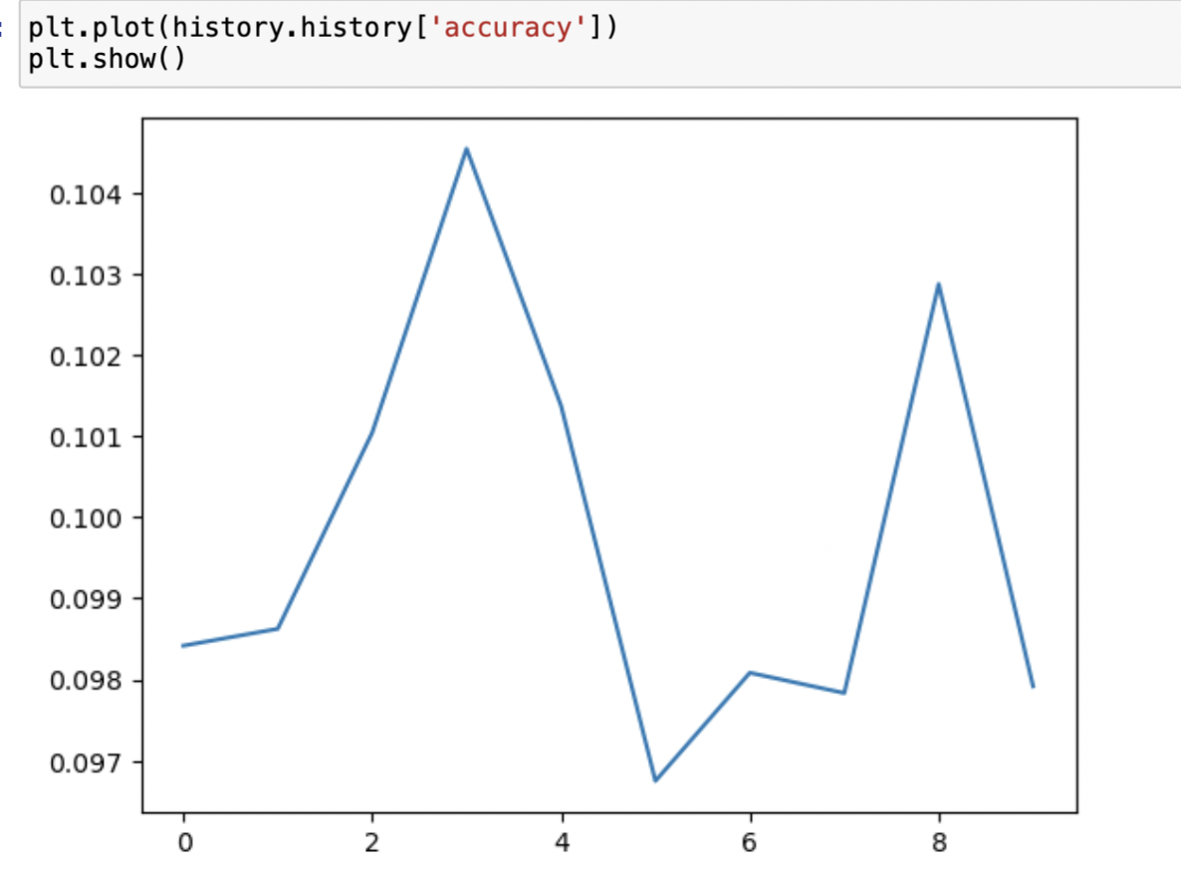

_,acc = model.evaluate(X_test,Y_test,batch_size=32,verbose = 1)

Finded best accuracy which was 60 % but couldnot have goot accuracy on train data as model had underfitting which couldnot be resolved due to less time.